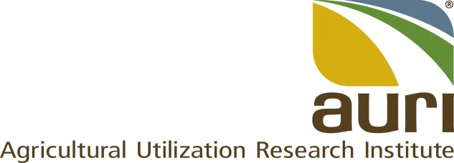

POSITION DESCRIPTION

Title: | Senior Director of Science and Technology
Employee: | TBD
FLSA Status: | Exempt
Reports to: | Executive Director
Location: | TBD
Supervisees: | 6
Avg # travel days per month | 8
Purpose: | Lead and direct AURI’s diverse research and development strategies, including oversight of staff and laboratories. Collaboratively lead the organization to impactful research outcomes through commercialized products and processes.

The following are examples only and are not intended to be “all inclusive” or restrictive. Other duties may be assigned as necessary.

Responsibility | Job Task | Percent of Time
Lead and direct AURI’s research and development efforts. | - Construct and implement an overall research and development (R&D) strategy, in cooperation with senior leadership, to identify impactful commercial opportunities.  - Review relevant literature and information to assure R&D plans benefit value-added agriculture in Minnesota.  - Develop and expand agricultural and academic networks and partnerships in Minnesota, the upper Midwest, nationally and internationally.  - Communicate and expand emerging innovations and technologies consistent with AURI’s mission.  - Ensure consistency and equal access of diverse communities in the development and management of programs and services in alignment with AURI’s values.  - Direct AURI’s R&D programs.  - Maximize laboratory impact through capacity and needs analyses.  - Manage AURI’s intellectual property and client activities, e.g., patents, trade secrets, trademarks.  - Identify potential revenue streams from intellectual property.  - Contribute significantly to research funding proposals to ensure high-quality submissions in alignment with strategic priorities.  - Create and implement accurate and up-to-date scientific and technical plans.  - Develop and manage departmental budgets.  - Analyze expenditures, needs and cost projections.  - Identify funding sources.  - Ensure cost effective alternatives and explore value trade-offs when planning expenditures.  - Approve budgeted expenditures.  - Review spending reports and adjust budgets as necessary.  - Serve on senior leadership teams.  - Collaborate with peers to advance organizational operations and opportunities. | 75%
Lead and guide AURI’s science staff and laboratories. | - Guide staff work to fulfill relevant strategic objectives.  - Ensure supervisee’s awareness of and adherence to all AURI policies and processes.  - Direct the development, management and operational plans of laboratories.  - Establish laboratory safety objectives in partnership with the Director of Organizational Advancement and the safety committee.  - Oversee the compliance and implementation of allocated resources for labs. | 20%
Other responsibilities | - Perform other duties as assigned.  - Gather and promote ideas for continuous process improvement.  - Participate in and actively promote AURI’s values and culture strategies. | 5%

Qualifications
Required

- Master’s degree in food science, engineering, biology, chemistry or a related value-added agriculture field.
- Ten years of recent research and development and commercialization experience, including progressive leadership and supervisory roles.
- Demonstrated experience in leading inclusive, diverse teams.
- Broad supervisory experience.
- Evidence of creating measurable results with individual and team accountability.
- Comprehensive management experience, including:
  - Strategic planning, program development, resource identification, departmental budget forecasting and resource management.
  - Analyzing and interpreting general business information, professional journals, technical procedures or governmental regulations.
- Experience administrating intellectual property, technology acquisition and transfer.
- Extensive agricultural industry and academia networks.
- Strong negotiation and influencing skills that lead to mutually beneficial outcomes
- Synthesized knowledge of Minnesota’s agricultural landscape.
- Excellent intrapersonal and communication skills.
  - Outstanding presentation and negotiation skills.
  - Ability to clearly speak and conduct business in English.
- Computer and database proficiency.

Preferred
- Ph.D. in food science, engineering, biology, chemistry or a related value-added agriculture field.
- Fifteen years of recent research and development and commercialization experience, including progressive leadership and supervisory roles.

Job Demands
- Extensive sitting and driving.

