Minnesota Renewable Energy Roundtable
Renewable Chemicals

Wednesday, March 14, 2018

9:00 am-2:30 pm

University Enterprise Labs

1000 Westgate Dr.

St. Paul, MN 55114

8:30 a.m. Registration, refreshments and networking

9:00 a.m. Welcome and overview

9:20 a.m. Keynote Speaker: Dr. Toby Ahrens, National Program Leader, NIFA-USDA “Opportunities with NIFA”

10:05 a.m. Sun Grant Panel
Moderator: Dr. Vance Owens, Regional Director, North Central Regional Sun Grant Ctr., SDSU “Sun Grant Funding for Renewable Chemicals”

Panelists:
- Dr. Gregg Johnson, Associate Professor, Dept. of Agronomy & Plant Genetics, Biomass Cropping Systems, Southern Research and Outreach Center-Waseca, University of Minnesota “Feedstock Development for Renewable Chemicals and Other Bioenergy”
- Dr. Goutham Vemuri, Chief Technologist, Sasya LLC "Developing Renewable Chemicals from Crop Residues from Biomass Sugars”
- Dr. Qi Hua Fan, Associate Professor, Depts. of Electrical and Computer Engineering & Chemical Engineering and Materials Science, Michigan State University “Energy Storage Options Using Renewable products”

11:05 a.m. Networking Break

11:20 a.m. Financing and Technology Support Panel
Moderator: Michael Sparby, Senior Project Strategist, AURI

Panelists:
- Kevin Hennessy, Bioenergy Manager, Ag Marketing and Development Division, MN Department of Agriculture
- Pat Dillon, CDR, USN (Ret.) Director, MN-SBIR, Minnesota Innovation and Commercialization Consortium; Minnesota High Tech Association

12:05 p.m. Lunch

12:55 p.m. Highlight: Entrepreneur in Renewable Chemicals

Dr. Goutham Vemuri, Vice President of Technology Development, Aemetis Inc.

1:15 p.m. Bioeconomy Panel
Moderator: Rod Larkins, Senior Director of Science and Technology, AURI

Panelists:

Brendan Jordan, Vice President, Great Plains Institute, Lead Staff for Bioeconomy Coalition of MN

Dr. Eric Singsaas, Initiative Director-Wood Products and Bioeconomy, NRRI and Entrepreneur
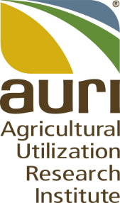

1:55 p.m. Table Discussion

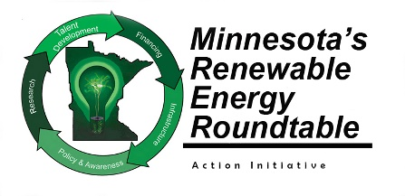
2:25 p.m. Wrap Up

